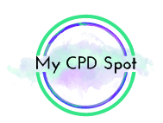
Evidence-Based Intervention for Children
with Speech Sound Disorders
With Caroline Bowen - 9th & 10th May 2017

EVENT DETAILS

Q. How do I get to the Carlton Hotel Dublin Airport?
A. There are a number of transport options to reach the Carlton Hotel Dublin Airport. These include:
- Car with free parking on site. http://www.carltondublinairport.com/en/location/
- Free shuttle bus from Dublin airport every half hour. See the Carlton Hotel website for more details. http://www.carltondublinairport.com/en/airport-shuttle-bus/

Q. Where can I stay?
A. Contact the Carlton Hotel directly for a delegate rate on +353 1 866 7500 or see http://www.carltondublinairport.com/

Q. Is lunch included?
A. No. There is a restaurant on site where lunch can be purchased. Morning and afternoon tea are included.

Q. How can I order a copy of ‘Making sense of Interventions for Children with Developmental Disabilities?’
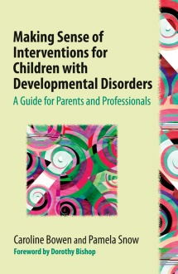
A. Once you have registered, a flyer will be sent to you to order the book directly from the publisher at the special price of €25. Books will be available for collection at the course. Please note that the publishers must receive your order by the 5th April to ensure you can collect your book on the day. A limited number of discount flyers will also be available at the course; however no books will be available for purchase on the day.

Q. Will I get a certificate for my CORU portfolio?
A. Yes, certificates will be available at the end of day 2.

Q. How do I register?
A. Please complete the form below and email (preferred) to mycpdspot@gmail.com or post to
My CPD Spot, 20A Laghtagoona, Corofin, Co.Clare. Places will not be confirmed until full payment is received.

___________________________________________________________________________________________
REGISTRATION FORM
NAME:_____________________________________________________________________________________
EMAIL ADDRESS:_____________________________________________________________________________
ORGANISATION:_____________________________________________________________________________
How did you hear about the workshop?__________________________________________________________
PAYMENT METHOD Direct transfer (preferred) Cheque / Postal Order (in €)
Bank: Bank of Ireland Payable to: My CPD Spot Ltd
BIC: BOFIIE2D Post to: 20A Laghtagoona, Corofin, Co.Clare
IBAN:IE47BOFI90421028800069
Please ensure you include your full name in the reference field.
Please add me to your mailing list so I can be kept up to date about upcoming courses
Refund Policy: No refunds will be given if you are unable to attend, however name changes will be permitted up to the 4th May 2017

